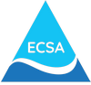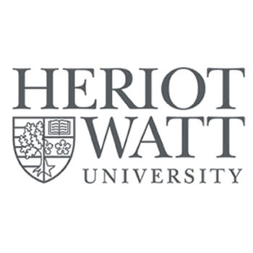

Estuarine and Coastal Sciences Association
Focus Meeting
“Scotland’s East Coast: Integrating Local Science, Management, and Broader perspectives”
Heriot Watt University, Edinburgh
12-13 May 2026

Name:
Affiliation:
Email:

Please submit 1 form per delegate
Tick below as required:
Standard delegate rate £ 85 □
ECSA Member £ 75 □
ECSA membership No: ----------------

If you have any accessibility requirements, please email: awith@noc.ac.uk
The registration fee includes refreshments during the event. Please indicate here if you have any dietary requirements or restrictions:
Ways to pay: (tick method selected)
□ direct bank transfer to the ECSA account (preferred option)
(please send an email to awith@noc.ac.uk when this is done)
Payment must be made in Sterling. If you are paying in another currency from an overseas bank please make sure that you bear the conversion cost.
Please transfer to the ECSA bank account:
Account name: Estuarine & Coastal Sciences Association
Bank of Scotland
Branch: 75 George Street, Edinburgh, EH2 3EW
Sort code 80-02-24
Account number: 00373053
When making a bank transfer please give surname and Focus Meeting in the payment description so we can identify the payment.

Those making payments from abroad:
IBAN GB86BOFS80022400373053
BIC BOFSGB21216
□ send a cheque payable to:
Estuarine and Coastal Sciences Association to:
Andrew Wither
National Oceanography Centre
6 Brownlow St.
Liverpool L3 5DA. UK.

If you require a formal invoice before making payment, please email: awith@noc.ac.uk
Please return form to awith@noc.ac.uk

